Wines of the South
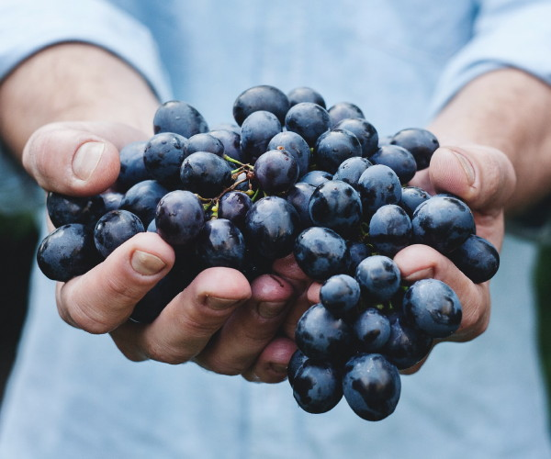
Chile & Argentina

February 2024

Perfect for foodies, wine enthusiasts and travel adventurers. This experience will allow you to taste Chile and Argentina’s history, food, wine, and culture. The journey will start in Santiago de Chile, one of South America’s most important wine producing countries; home to a variety of grapes, such as Cabernet Sauvignon, Merlot, Carmenere, Pinot Noir, Syrah, Cabernet Franc and Malbec, to mention a few. Then we will head over to Mendoza, Argentina through the stunning Andes Mountains. You will get to experience good food, wine and culture with wonderful people and meet new friends as we go.

DAY 1 Feb 18 Arrival at the airport
Welcome to Santiago, Chile! Santiago is not only the capital of Chile but it is also the best wine region in Chile. Set within the circle of snow-capped mountains, Santiago is vibrant, artistic and gourmet.
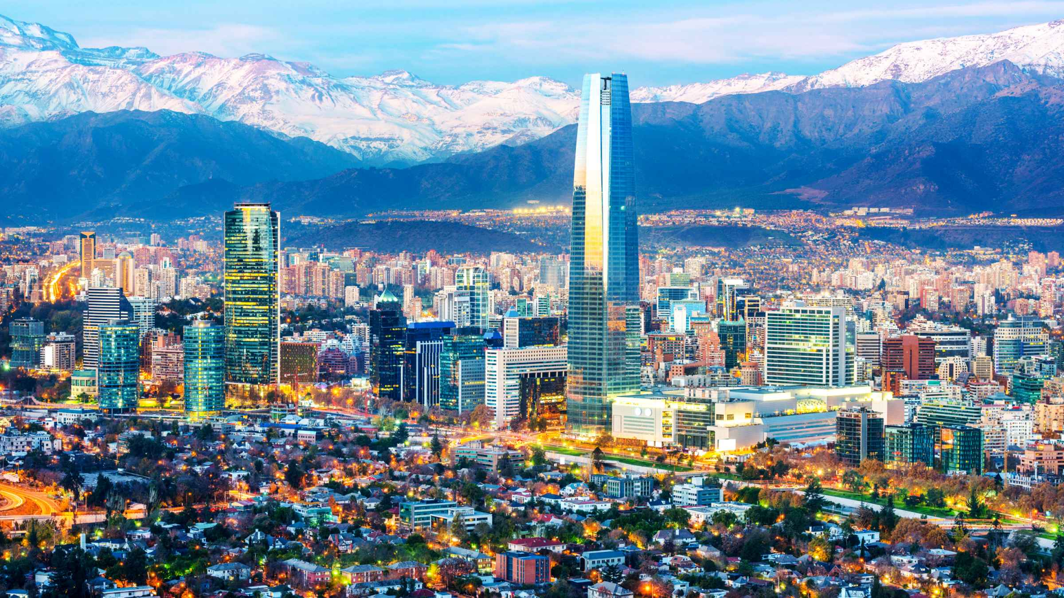
Upon arrival at Santiago de Chile International Airport,
A driver will meet you the airport and transfer you to your hotel.
Settle in at The Pullman Santiago Vitacura hotel,
6 pm we will meet at the Hotel bar to enjoy a welcome cocktail.

7:15 pm we will meet in lobby to take bus to head over to our restaurant Mestizo Restaurant 7 min drive Bus Ride (25 min walk) If after you want to stretch your legs.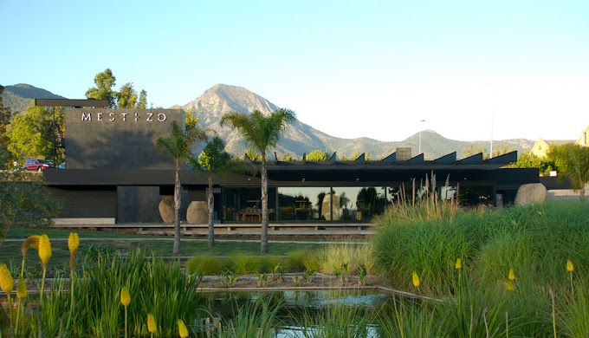

DAY 2 Feb 19 City Tours - Valparaiso
Enjoy your breakfast and be ready for a wonderful visit to Valparaiso .
Valparaiso is a port city on Chile’s coast, known for its cliff top homes, funicular (cable cars) and the home to the famous Chilean poet Pablo Neruda. The city has amazing street art and holds its own open-air museum in Cerro Bellavista.
We will meet Rodrigo a Local guide to show us around.
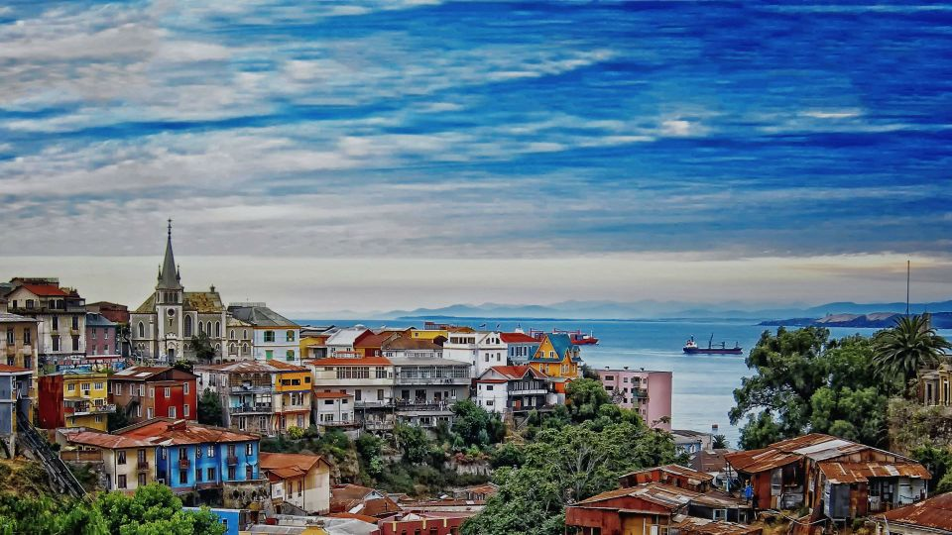
Meet at the lobby to be on the bus at
6:45 am bus pick up at hotel Pullman Vitacura the ride is 1.5 hours long to Valparaiso.
8:30 am arrive in Valparaiso at Plaza Sotomayor Hotel
Take the walking Tour of the city Valparaiso with Rodrigo.
11:30 am Have the bus pick us up at Valparaiso at Plaza Sotomayor Hotel to bring us to
Vina Casa del bosque.
When we arrive at Vina Casa Del Bosque for our first wine tasting of 4 of there beautiful wines!
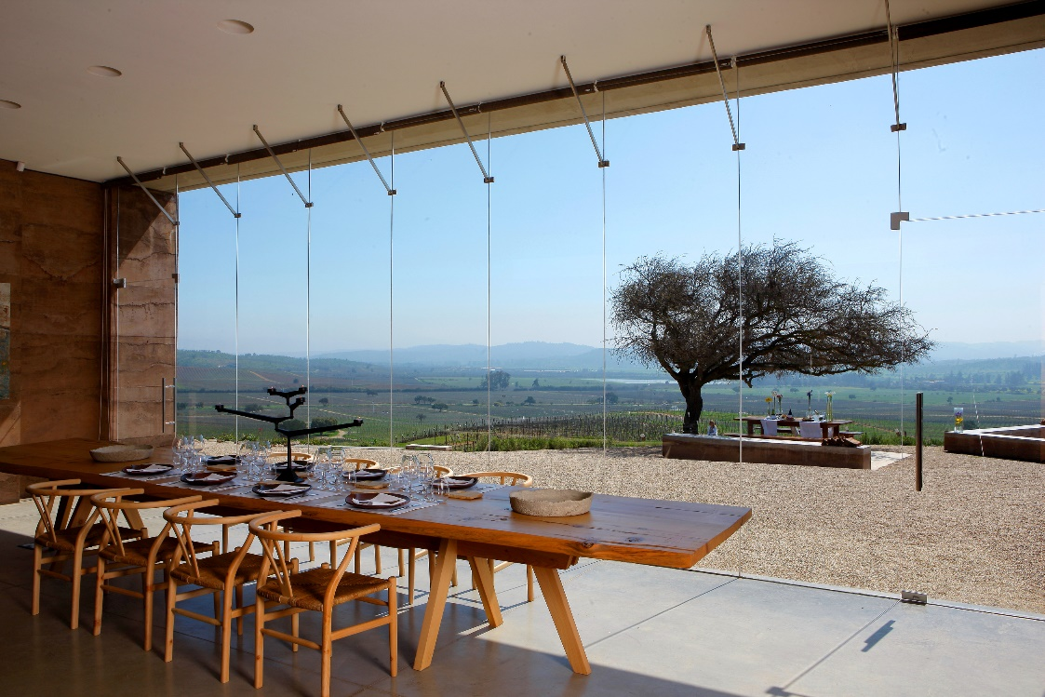
Casa Mirador
A magical and unique place, with a privileged view, where you can feel the sea breezes coming from the Pacific, due to the proximity of the coast and where we will find an old hawthorn tree, a typical Chilean species.
"We are like a ship that sails the sea of life. We are not the master of our fate, but the sailors of our soul." ~ Pablo Neruda

When we arrive to the winery we will start with a wine tasting for a wine tasting 4 wines.

This program is designed for lovers of good food, you can cook in our kitchen at Casa Mirador with a member of our gastronomic team and learn from their recipes. Enjoy what you just prepared with our best wines. Experience with an amazing view over the valley, surrounded by nature at its best and enjoying our wines.
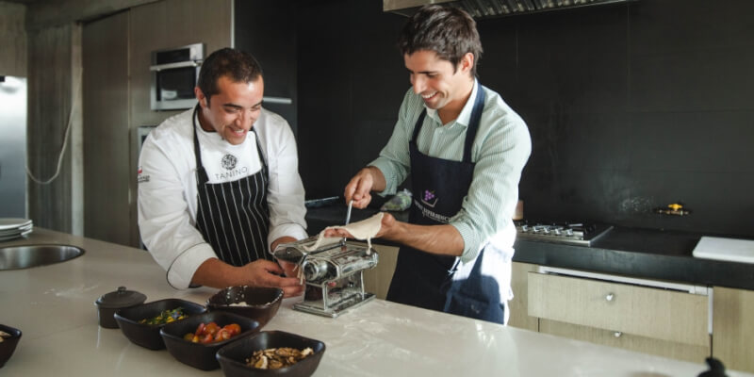

4:15 pm Bus will pick us up for our cooking class and wine tasting to bring us back to the
Pullman Vitacura hotel. 1 hour drive.
Then the evening is yours to relax or explore!

DAY 3 Feb 20 Concha y Toro Vineyard
Enjoy breakfast and get ready to visit the World-Famous Concha y Toro Vineyard. The property has beautiful scenery. “The Garden of Varieties” holds 26 unique grape varietals, and a picturesque atmosphere for all wine lovers. The Sommelier will share with you an amazing variety of wine collections for you to taste.
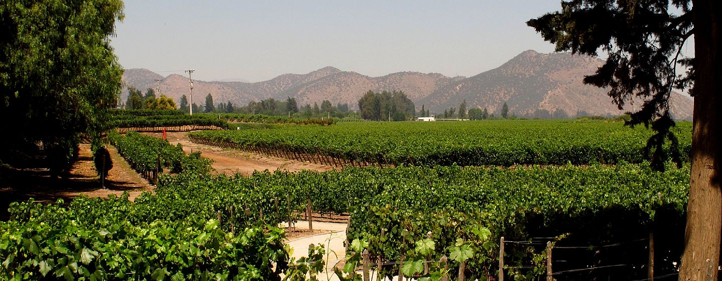

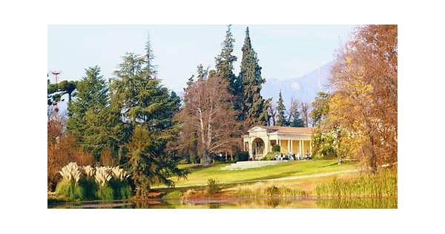
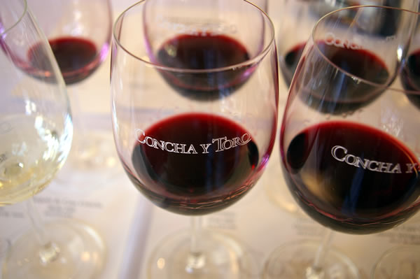

Concha Y Toro Vineyard

Feb 20-
Have breakfast at Hotel.
9:40 am Bus picks up at Hotel Pullman Vitacura to bring us to Concha y Toro PIRQUE winery 40 mins
10:40 am wine tour for Concha Y Toro wine tour and a premium wine tasting.
Bus will return us to hotel Pullman Hotel
Should be time to rest in between.
4:45 pm Bus will take us to drive us downtown for a city walking tour for those who would like to take part.
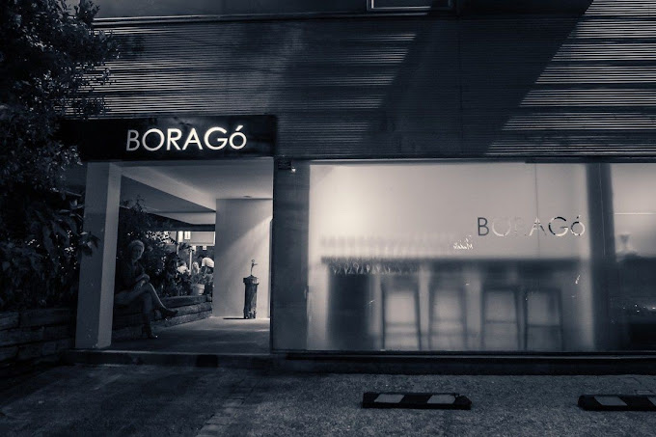
8 pm dinner a Borago Restaurant
We will have a private room in this restaurant. So excited!
“Top 50 best in the WORLD “ It will be a fun and interesting night food culinary experience.
A chief friend said this was a great experience can’t wait.

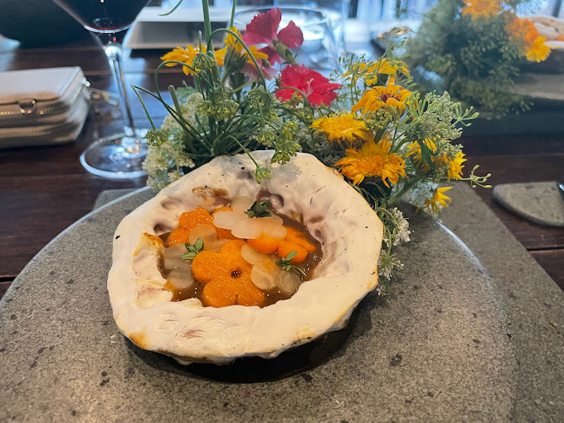
DAY 4 Feb 21 Blend Your Own Wine workshop at COLCHAGUA.
Pack up for the bus to leave the city go to the countryside.
9 am Bus pick us up with luggage at the pullman Hotel
Bus to take us to Vina MontGras
Drive is 2 ½ hours south but we will stop along the way to smell the rose.
12:30 pm Guided Vinyard Tour at Vina Mont Gras and blend our own wine classes. About 1.5-2 hours
We will have a professional guide with our wine making and tasting.
Super Pumped for this one… I really can’t wait!

Today is a chance for you to experience the art of wine making for yourself. Thanks to some hands-on activity at Colchagua’s Montgras winery.
This is a modern estate that has a fascinating collection of different grape varieties.
Our day will start with a vineyard visit and a look at the Montgras grape conservatory, before moving on to learn about one of the more practical aspects of wine making, namely wine blending. You’ll start with some raw material in the shape of tank samples of different grape varieties, and your task is to make the best blend, just as the winemaker does every year. As you will see, blending is not as easy as it looks, but there will be plenty of guidance and by the end of the workshop, you’ll have your very own blend, bottled and labelled, to take away.
I am so excited to do this experience I had to say it again lol.
We get to make,bottle and label our own wine!!
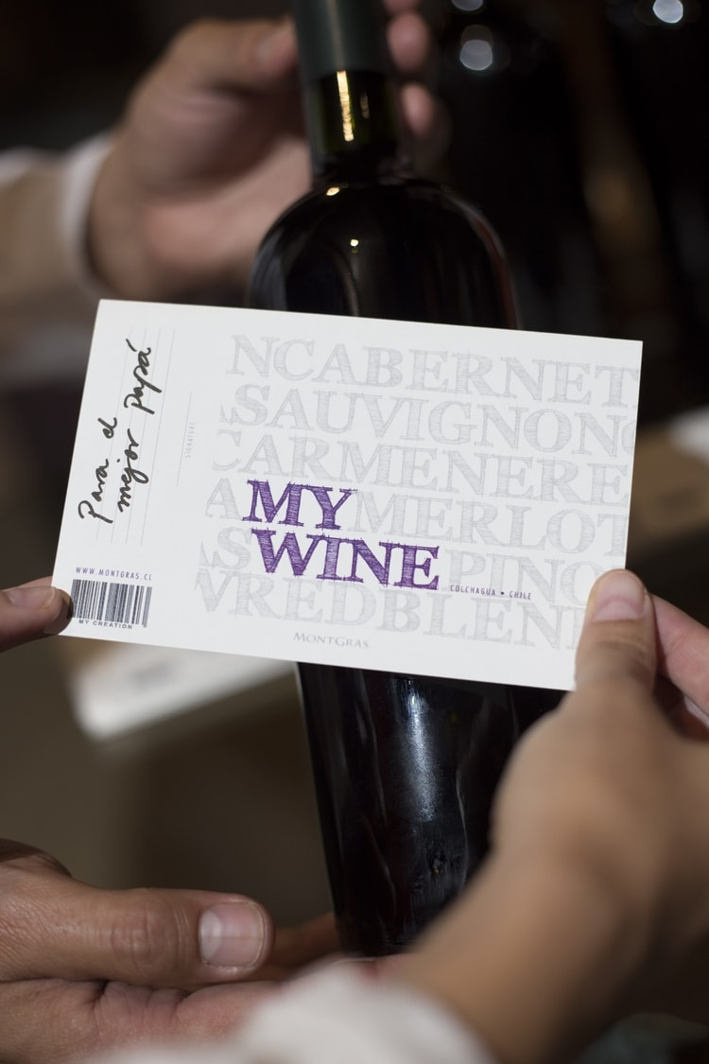
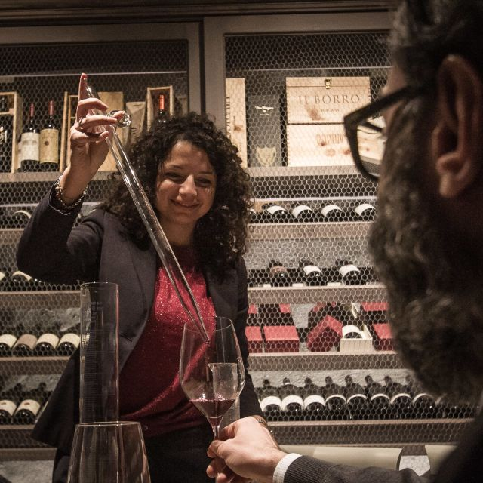

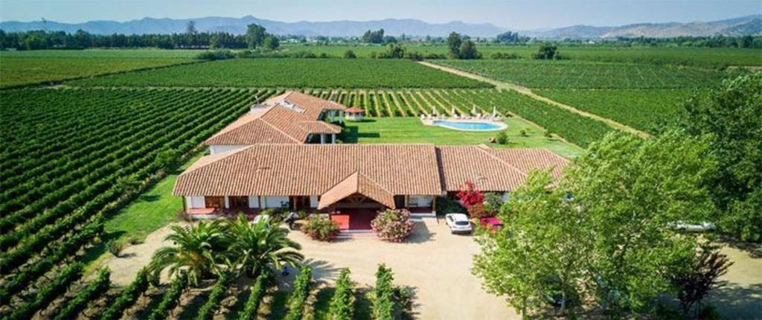
2:30 pm Bus will take us to our Hotel Terravina Only 11 mins away from the winery.
Go to Hotel and check in to our hotel have the afternoon to unwind in the countryside.
During your stay at Hotel TerraViña we recommend relaxing on the sun loungers by the pool, walking among the vineyards, enjoying a massage in your room (need to book ahead), exploring the area by bicycle.

7 pm We will meet for dinner at the hotel Restaurant.
This hotel Restraunt menu looks great and for the oyster lovers they have it on the menu!
Looking forward to chilling and a bit more time outside
can’t wait to see the stars in the south sky at night.

DAY 5 Feb 22 Say goodbye to Chile and head to Mendoza, Argentina
We are heading over the Andes Mountains to Argentina. This trip will take most of the day but rest assured, not all of it will be spent on a bus, as the border crossing will take some time.
This trip will take about 7-8 hours but the views are truly spectacular, and the landscape is magnificent. The border crossing point is at 3500 meters (almost 12,000 feet). In the distance you will see Aconcagua, the highest peak of the Andes and indeed of the Americas, standing proud at 22,831 feet high.
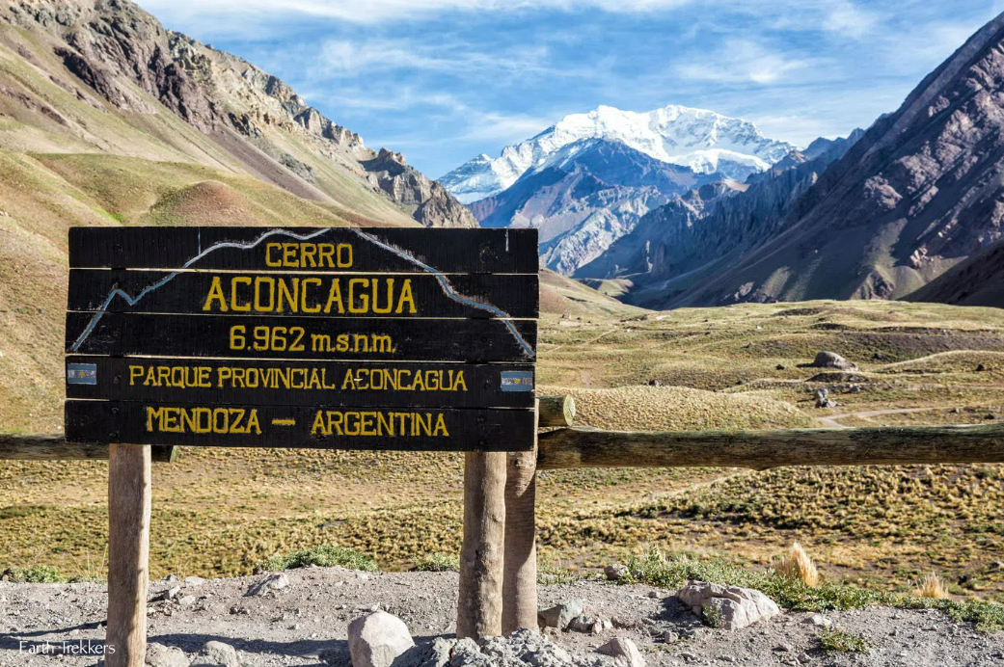
Mount Aconcagua
This is the tallest mountain in both the western and southern hemispheres. It is clearly visible on the drive over the Andes Mountains.

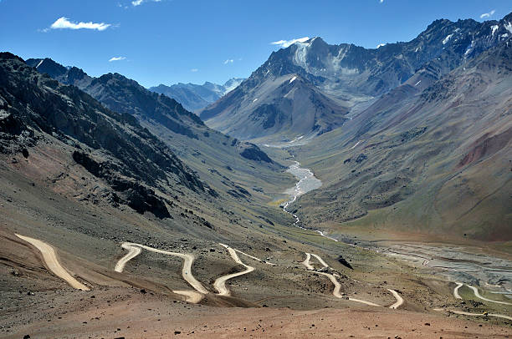
Hairpin roads on the journey over the Andes

Ok today will be an adventure and with Travel Rod and I always have story of our adventure’s.
This Road might just be it!
Mendoza Hotel

Portal Plaza Suites Hotel
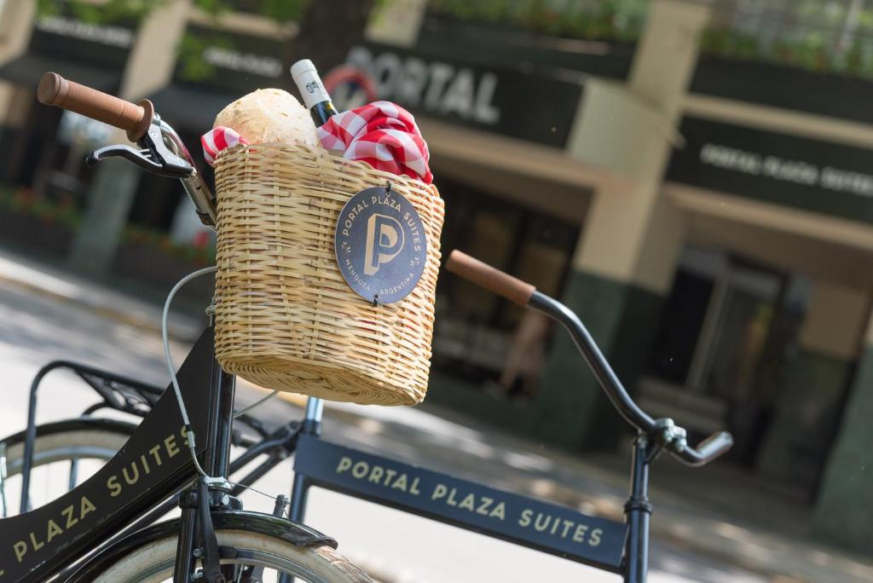
You can take in the view of the mountains while relaxing in the rooftop hydromassage tub
The hotel also gives you the opportunity to exercise with free bicycles to get to know the city.

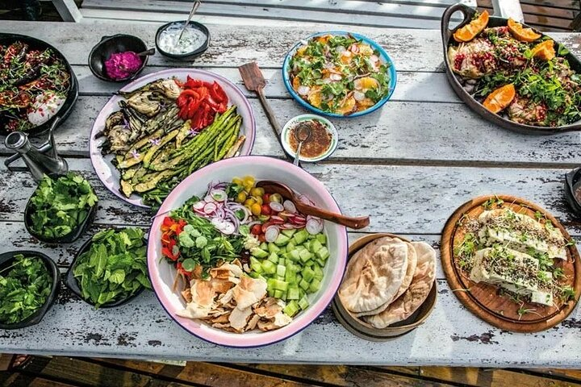
DAY 6 -Feb 23 Mendoza BBQ and wineries day
We will have the opportunity to live a unique Mendocino day in which they will visit excellent wineries, taste their wines and then enter the World of Barbecue. At this moment we will share in a unique table the experience of the true Argentine Roast, its way of doing it, its rituals, the Fernet, the Chori, the Meat, the Chimi. A whole gastronomic experience.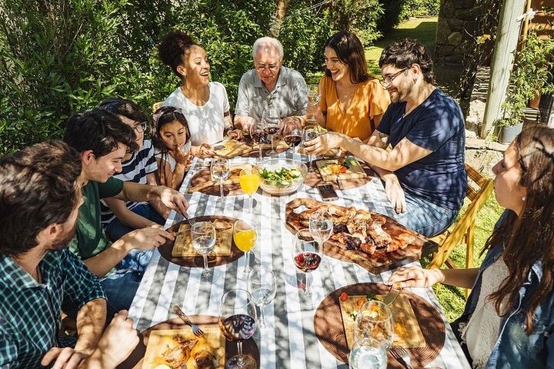 
Hotel Breakfast
10 am Argentine BBQ Experience 7 hour tour today with 7 wineries and bbq. The Evening is yours to explore.

Day 7 -Feb 24 Lorca Winery
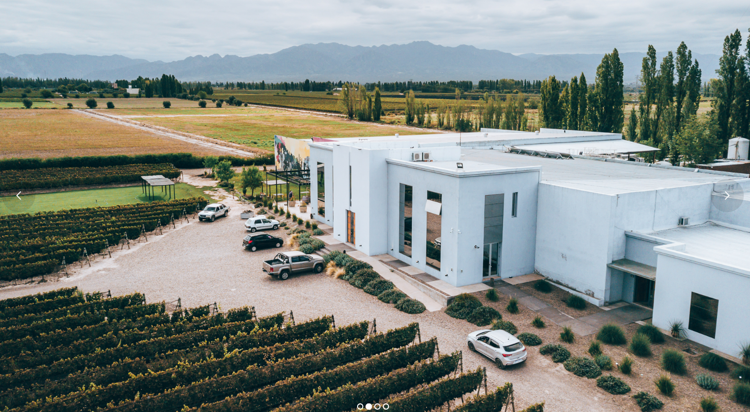
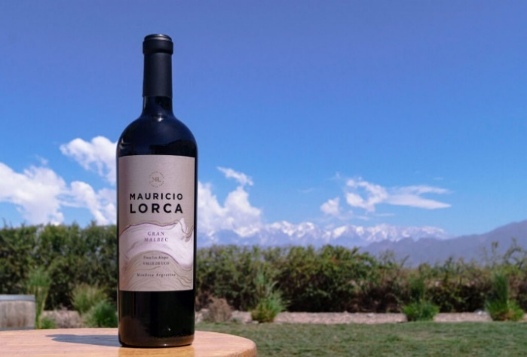
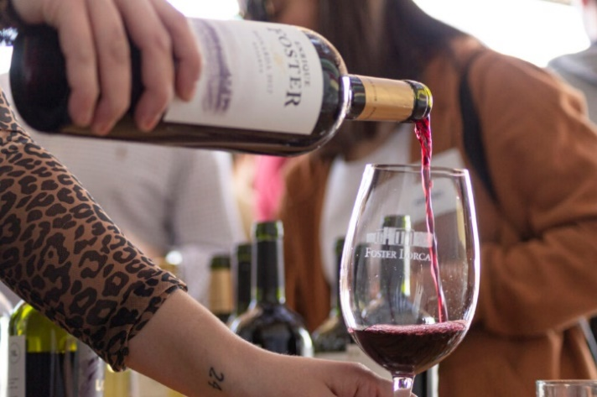

Bodega Foster Lorca

Day 7 -Feb 24 Lorca Winery
Have a breakfast then get ready for our visit to Lorca Winery
10:15 am Bus to take us to Bodega Forster Lorca winery 30 min drive.
11 am, we have a for a wine tasting and then to have lunch at the beautiful winery restaurant.
2pm bus will return us to Portal Plaza Suites Mendoza
Back to the hotel with a free afternoon maybe visit the pool get some sun.
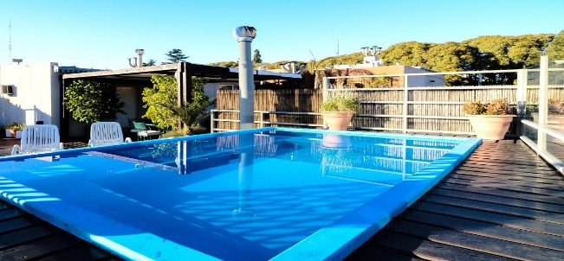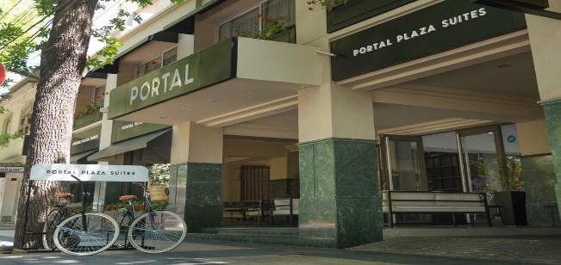
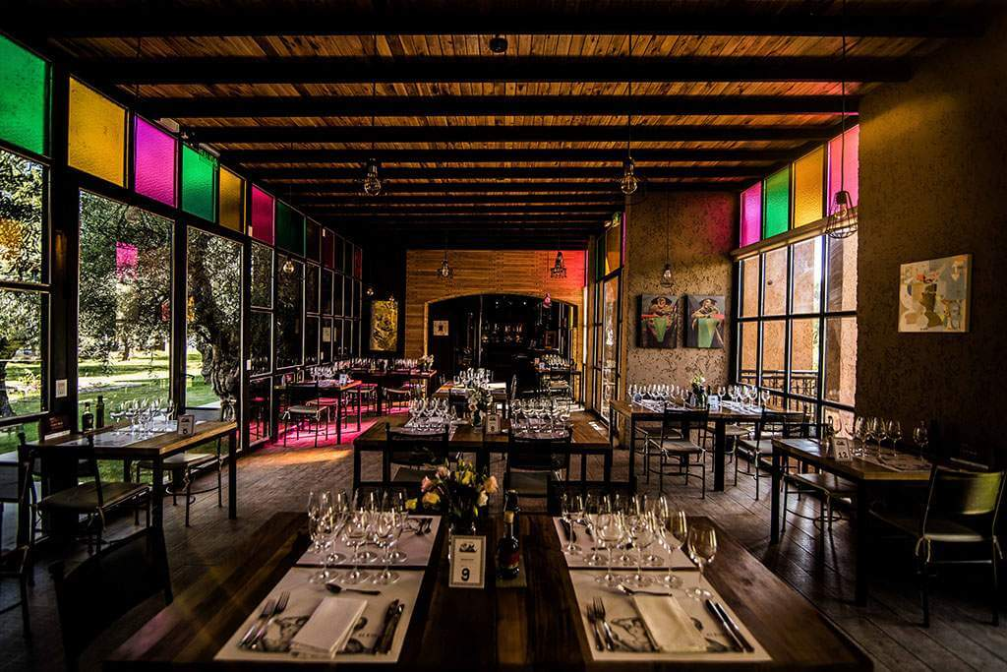
Casa Vigil Restraunt

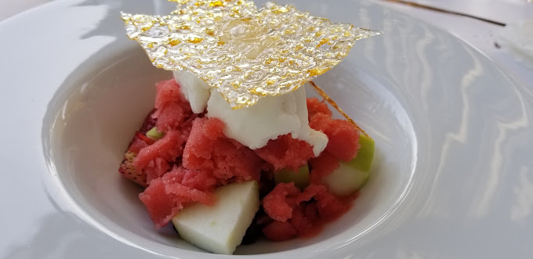
7:30 pm Bus to take us to dinner drive is 30 min drive.
8 pm dinner Casa Vigil Restraunt
We will have a 7-course dinner.
11 pm bus will return us to our hotel.

This is our farewell Dinner this is a special restaurant it is on the Top 50 best Restaurant in the World
So excited for this special tasting menu.

Day 8 -Feb 25 Day to Head home
Goodbye, Argentina!
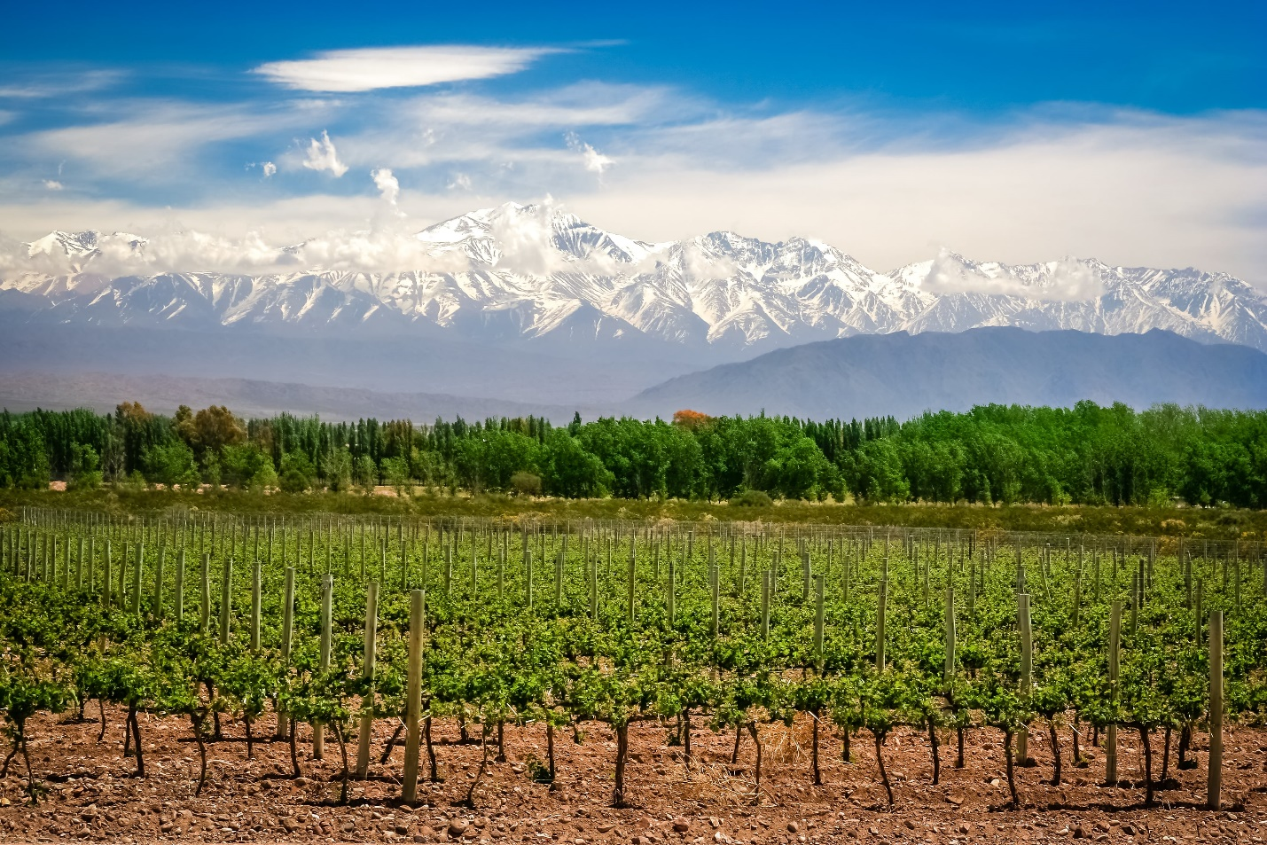
We will get you to the Mendoza airport to catch your flights back home.
Adios! Goodbye! Adieus!
Rod and I are so grateful
to have you join us in our adventure of South America and to share our Love of Travel.
Thank you so Much!
World Of Wine Tours Inc

